Gibraltar bridge

A bridge spanning 9 miles over the Straits of Gibraltar at the entryway to the Mediterranean would be the longest and tallest ever built. It would connect cultures of Christianity and Islam and potentially increase ties between the economies of Europe and Africa.

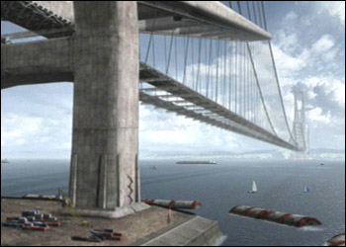
Gibraltar Bridge
The proposed bridge over the Straits of Gibraltar would allow automobile traffic between Spain and Morocco.

Stats:
Location: Strait of Gibraltar. Links Spain and Morocco.
Length: 9 miles, Two spans of 4 1/2 miles each
Height: Each tower is 3,000 feet tall. Twice as high as the world's tallest skyscraper.
Width: 5 traffic lanes, 2 breakdown lanes in each direction
Road Deck Material: Fiberglass
Length of Wire Cables: 1,000,000 miles (Enough to circle the Earth almost 30 times)
Closest living relative: Akashi bridge in Japan, world's longest suspension bridge at 12,828 feet.
Cost: $15 billion
Dangers: Wind speeds of 80 mph at tops of towers, ship collision, ocean currents, traffic, Sahara Desert dust storms.

Withstand ship collisions and high winds.
A bridge the size and configuration of Gibraltar Bridge is usually protected by artificial islands built around its piers. That way, ships run aground before they can do any damage to the structure.

But artificial islands are not an option in the middle of the ocean. The Gibraltar Bridge designers instead envision a ring of underwater bumpers to withstand ship collisions.

Build in the open ocean.

When determining the exact site of the bridge, designers had to choose between a shallow area that spanned 20 miles, which would have meant many piers in a busy shipping zone, and a narrow portion that's 2,700 feet deep.

But the Gibraltar Bridge designers lucked out.
A closer inspection of the narrow portion revealed an underwater "mountain" in the center that could hold the center piers, dividing the bridge into two spans of 4 1/2 miles each.


Gibraltar Bridge — if stretched over NYC

Span 9 Miles

The longer the span, the heavier the bridge.
At the length required to span the Strait of Gibraltar
, a suspension bridge that supports the weight of the roadway with cables spanning from tower to tower would sag and ultimately collapse. A cable-stay bridge that attaches cables directly to the roadway, would require unworkably high towers to support the length of the roadway.
Gibraltar Bridge's designers say why not use both techniques?
The Gibraltar Bridge design supports 3 miles of each 4 1/2 mile span with suspension cables, and the remaining 1 1/2 miles with a cable-stay technique attaching cables to diagonal struts on either side of each tower.

Keep the traffic flowing — and safely

Five lanes of traffic in either direction will flow over a roadbed made of spun glass.

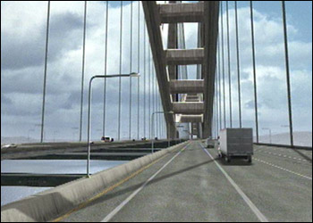
Traffic on Gibraltar Bridge
The Gibraltar Bridge's traffic will flow over a roadbed made of spun glass. Designers say five lanes in either direction should be enough to handle the volume of vehicles.

Fiberglass materials of this sort are rated at five times stronger than concrete, and any cracks or other damage could be isolated due to its web-like internal structure

Engineers say fiberglass bridge materials can last up to 100 years. They're also easier to install. A concrete roadway on Gibraltar Bridge would take 3 months to pour as opposed to a few days or weeks with fiberglass.

