Calcuta-the most beautiful tourist place on earth

History of Calcutta
Although the name Kalikata had been mentioned in the rent-roll of the Great Mughal emperor Akbar and also in Manasa-Mangal, to explore the history of Calcutta, we have to go back to the 17 th. century. It was in 1690....Job Charnock came to the bank of the river Hooghly (it's the part of the Ganges) and took the lease of the three villages- Sutanuti, Govindapur and Kolikata(Calcutta) as a trading post of British East India Company. The city became famous in 1756, when Siraj-Ud-Dawlah, the last independent nawab of Bengal, captured the city . But the British regained their power in 1757 and the city was recaptured under Robert Clive. Warren Hastings, the first Governor-General of India, made it the seat of the supreme courts of justice and the supreme revenue administration, and Calcutta became the capital of British India in 1772. By 1800 Calcutta had become a busy and flourishing town, the center of the cultural as well as the political and economic life of Bengal.

Calcutta - Landmarks, memorials and places of interest you can visit

- Shahid Minar : Previously known as Ochterlony Monument, located in the heart of Esplanade. The panoramic view of the city from the top of the monument is really captivating. With 218 steps, this 52 meters high monument consists of a combination of Egyptian base, Syrian column and Turkish copula.
- Birla Planetarium : Located at the top end of Chowringhee, the only planetarium in the country, whose dome houses a collection of projectors and optical equipments expensively imported from East Germany. It is the largest planetarium in South-East Asia and the 2nd. largest planetarium in the world.
- Victoria Memorial
- Rabindra Sadan
- Nandan
- Academy of Fine Arts
- Jorasa(n)ko Tagore House (Thakurbari) : The world famous poet Rabindranath Tagore was born and died in this house. Located at the junction of the Chitpur Road and the Vivekananda Road, it is the headquarter of Rabindrabharati University, a famous center for the study of the Indian Arts. There is a museum too in memory of the great Tagore family.
- Marble Palace
- National Library : India's the largest library; contains huge collection of rare books and manuscripts.
- Fort William: citadel of Calcutta . With the permission of the Nawab of Bengal, this fort was built between 1696 and 1702 by the British East India Company and named after King William III of England. In 1756 the fort was taken by the Nawab of Bengal, Siraj-ud-dullah. In 1757 East India Company regained their power and demolished this fort and they started reconstruction of the fort. The new fort was completed in 1773 and it is still there.
- Rajbhavan
- Ramakrishna Mission Institute of Culture
- Netaji Bhawan: where Netaji Subhas Chandra Bose lived and worked. His personal belongings are on exhibition here.
- Aurobindo Bhawan
- Birla Academy of Arts and Culture
- Kala Mandir
- Mahajati Sadan
- Gorky Sadan
- Rabindra Sarovar
- Sisir Mancha

Calcutta - Parks and stadia

- Eden Garden
- Botanical Garden : The garden was founded in 1787 by the East India Company and formerly known as Royal Botanic Garden. It is famous for its huge collection of bamboos, orchids, palms and the plants of screw pine genus. The area of the garden is more than 270 acres and more than 1700 plant species can be found. The Central National Harbarium of the Botanical Survey of India is here and has 2500000 dried plants in its collection.
- Zoological Garden : laid in 1876, extending over an area of 16 hectares, it has considerably large collection of animals. White tiger, tigon ( a hybrid between tiger and lion), the reptiles (huge collection), the Royal Bengal tigers are the special exhibits. During winter, the migratory birds from all over the world are the special attractions.
- Rabindra Sarovar Stadium
- Ranji Stadium
- Race Course
- Victoria Memorial Garden
- Golf Course
- Polo Grounds
- Bidhan Children's Park : a great place for kids.

Calcutta - Museums

- Indian Museum : the oldest museum in India and one of the most comprehensive museums in Asia; the archaeology and numismatic sections contain the most valueable collections.
- Art Industry Museum
- Nehru Children's Museum :It's a great entertaining place for the children, named after the first prime minister of India,Pandit Jawaharlal Nehru. It's located at Jawaharlal Nehru Road (formerly Chowringhee Road). The stories of the Ramayana and the Mahabharata have been depicted nicely with the help of the animated dolls. Some science models are also on exhiibition; must see for the kids.
- Ashutosh Museum : maintained by the University of Calcutta; housed lot of exhibits on the folk art of Bengal.
- Victoria Memorial Museum
- Birla Industrial and Technological Museum
- Floating Museum: world's first floating museum , located at the "Man-o-War" jetty.
- Rabindra Bharati Museum

Calcutta - Places of Worship and Meditation

- Belur Math : headquarter of Ramakrishna Mission Ashram, founded by Swami Vivekananda
- Dakshineshwar Kali temple
- Kali Temple, Kalighat
- Nakhoda Mosque : the largest mosque in Calcutta which can accomodate 10000 worshippers at a time; built in Indo-Saracenic architecture style.
- St. Paul's Cathedral Church : the most important church of the city; located in between Birla planetarium and Rabindra Sadan.It was constructed by Bishop Willson in 1847 . It is the first Episcopal Church of the East. The Indo-Gothic style architecture of this church is really impressive.
- Parshnath Jain Temple
- Parsi Temple
- Mother Teresa Mission of Charity
- Jewish Synagogue
- International Society of Krishna Consciousness
- Mahabodhi Temple
- Japanese Buddhist Temple
- Bara Sikh Sangat Sikh Gurudwara
- Tipu Sultan's Mosque
- St. John's Church : a beautiful old stone church laid in 1784.
- St. Andrew's Church
- St. Thomas Church
- Baikunthanath Temple
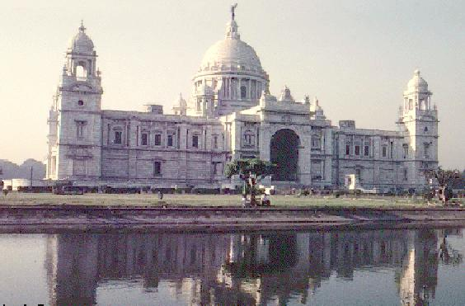

Accomodation – Calcutta Hotels

Luxary
Taj Bengal, 348 Belvedere Road, Cal-27 (Tel:2483939, Fax: 248 1766) Hotel Oberoi Grand, 15 J. N. Road, Cal-13(Tel: 2492323, Fax: 2911217) Best Western Kenilworth, 1 & 2 Little Russel Street, Calcutta- 71 (Tel: 4483949, Fax: 225136) Airport Ashok, Calcutta Airport, Cal-52 (Tel: 5529111, Fax: 5529137) Great Eastern Hotel, 1-3, Old Court House Street Hindusthan International, 235/1, Acharya J. C. Bose Road Ritz Continental, 12 J.N. Road, Cal-13 Ramakrishna Mission Institute of Culture, Golpark YMCA, 25, J. N. Road, Cal-13 Minerva Hotel, 11 Ganesh Chandra Avenue Park Hotel,17 Park Street

Moderate
Air Continental Lodge, 2 Airport Gate, Dumdum Asia Hotel, 11 A & B Jamir Lane, P-1A, Rash Behari Avenue Santiniketan Hotel, 16B Mahatma Gandhi Road Capital Guest House, 11B Chowringhee Road Park Guest House (P) Ltd.20/C Gariahat Road(South), Dhakuria Saket, 23 Mukhram Kanoria Road Saptarshi, 23 Gariahat Road, Goal Park Sunview Guest House, 20/1/1A, Ballygunge Station Road
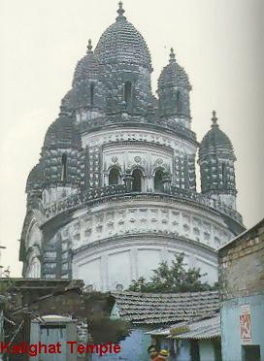

Elev:Ciupitu Bogdan Mihai Clasa:XG

