Millenium tower

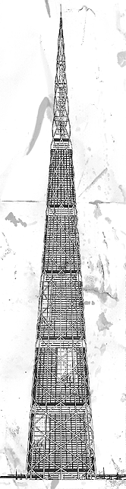

Imagine a skyscraper almost twice the size of the Empire State Building. This colossus would be a city within a city, hosting its own hospitals, schools, and a range of entertainment and retail options large enough to attract and keep the traffic necessary for the financial success of such an endeavor.

840m high, the Millenium Tower in Tokyo will be almost twice the height of Chicago's Sears Tower, currently the world's tallest building. The Millenium Tower will be as large as a small town but it will be built straight up.

The tower is designed to hold 50,000 people and support a mixture of work and leisure activities. Town squares, or 'sky centres' will be located every 30 floors, dividing the floors above and below into localities similar to neighbourhoods.

High speed lifts will carry up to 150 people through the tower's helical steel structue. There will also be conventionally-sized high speed lifts to service smaller groups. The larger elevator will be akin to a bus, and the smaller, to a car. When buildings get this large, even the smallest issue has the potential to be an enormous problem for designers.

Must be earthquake- and wind-proof.

In the harbor of Hong Kong, Millennium Tower will have to withstand monsoons and powerful earthquakes.Designers determined a round structure would alleviate the wind resistance found in a traditional rectangular building. And varying its width from top to bottom would help to dissipate vibration. Millennium Tower's height may also actually help it shake slower than its smaller counterparts during an earthquake. With the addition of dampers and motion-sensors, engineers expect the tower to withstand an earthquake of magnitude 8.6 on the Richter scale, and winds of up to 200 mph.

Get people where they want to go — and fast.

Even though they could be built to run up to 34 mph, passengers' eardrums could rupture at that speed, so the elevators will probably run at around 15 mph.Some cars will hold about 160 people and express elevators will stop at "sky lobbies" located every 30 floors where passengers can change to local service.Other cars may even be able to move horizontally. Innovations like these may be necessary to move about 100,000 people a day.

Give the people what they want.

Beyond the physical challenges of building the tallest skyscraper in the world, it will only be successful if it attracts residents, tourists and offices.
The Millennium Tower needs to offer many choices to make it a destination of choice. Residents can go to not just one grocery store, but many. Office workers can browse a few clothing stores on their level or the same amount 30 floors up. Tourists can find the movie they want in at least one of the many theaters available. Designers say Millennium Tower will house as many options as you'd find in several city blocks.

Build it quickly, but safely.

Construction of the Millennium Tower will include traditional building techniques, that, in this case, will put ironworkers thousands of feet in the air to place 5-ton girders with a minimum of safety gear. But engineers are planning to also use a new technology — building by computer.The Self-Rising Factory is a set of computerized cranes and lifts surrounded by a weatherproof enclosure. According to a precise schedule, the steel beams are essentially handed to the machinery which then places them for workers to bolt together. Once the beams and concrete panels for each floor are complete, the machinery hoists the entire structure and the process starts over.

