Viewing / Photographing specimens Using the
Transparent Electrode or Film Plate
POSITIVE POLARITY METHOD
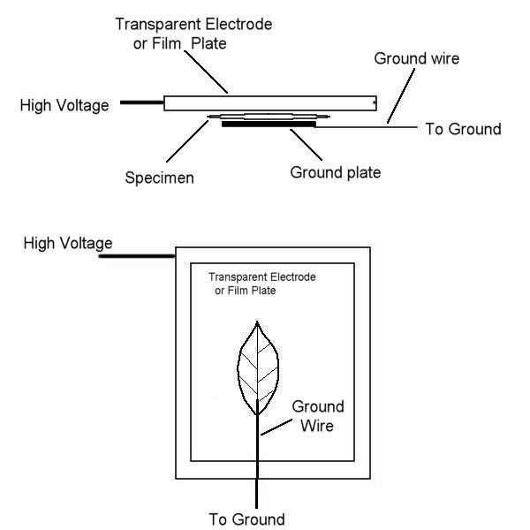
This Diagram illustrates two methods of viewing or photographing a specimen such as a leaf or coin.
In the top image, The transparent electrode or film plate is connected to the high voltage output of the kirlian power unit. A ground plate is fabricated out of aluminum foil or sheet metal, slightly smaller than the specimen. This ground plate is placed upon a non-metallic table top. A very thin, bare wire is connected to the ground plate. It is not necessary to solder the wire as long as it is just touching the plate it will be OK. The specimen is placed upon the ground plate so that it covers the entire ground plate. The wire is then connected to the black Negative High Voltage Output jack of the Kirlian unit. The transparent electrode or film plate cable is connected to the Positive High Voltage and laid upon the specimen. You may have to adjust the positioning of the electrode or film plate to assure it is resting EVENLY on the specimen to make an even coronal discharge.
The bottom image represents another method which does not make use of a ground plate. The specimen is simply placed on top of the bare ground wire, contacting it. Connections are made the same as above.

