Achiziţii de date cu ajutorul unei interfeţe SOUNDBLASTER

Autor: sani

Intoducere

În acest document este descris un program în C/C++ de achiziţii de date cu ajutorul unei interfeţe SOUNDBLASTER, şi prelucrarea semnalelor care permit:
- calculul funcţiilor de autocorelaţie
- calculul funcţiilor de intercorelaţie

Principiul funcţionării

Programul foloseşte o placa SOUNDLBLASTER pentru achiziţionarea semnalelor, semnalul analogic (continuu) este convertat în semnal digital (discret), care este prelucrat de program care realizează funcţiile cerute.

Cerinţe

Calculator >386
OS: DOS >6.20 (Win9x,Win XP,NT,2000)
Placa SOUNDBLASTER
Monitor VGA

Programul a fost testat pe un sistem cu OS: Win98, SVGA, placa de sunet C-Media Inc.8330 (compatibil SB16), pe acest sistem programul funcţionează stabil.

Descriere program

Programul principal 123.exe,utilizează biblioteca grafică egavga.bgi.Are ca argument 0,1,2:
- 0 – doar osciloscop
- 1 – osciloscop + fct. de autocorelaţie
- 2 – osciloscop +fct. de intercorelaţie

În program sunt utilizate:
IRQ,DMA,VGAPAGEFLIP.etc
Programul foloseşte o placa SOUNDBLASTER pentru achiziţionarea semnalelor
Semnalul analogic este aplicat la intrarea de microfon a plăcii SOUNDBLASTER.

Semnalul analogic (continuu) este convertat în semnal digital (discret) de CAN din placa SOUNDBLASTER. Structura principial este reprezentat în Figura 1:
Programul foloseşte acest convertor analog-digital pe 8 biti.(În cazul SB16 acest convertor este pe 16 biţi dar se poate folosi şi pe 8 biţi)
Transferul de date se face prin DMA.
Pentru a funcţiona corect pentru placa SOUNDBLASTER trebuie să fie setat următorii parametrii:
- Adresa de bază 0x220
- IRQ 5
- DMA 1
Programul nu detectează automat setările, dacă placa SOUNDBLASTER are alte parametrii trebuie modificat fişierul sbaster.h,dma_mem.c
Programarea unităţii DSP (Digital Signal Processor) din placa SOUNDBLASTER,se face prin porturi.

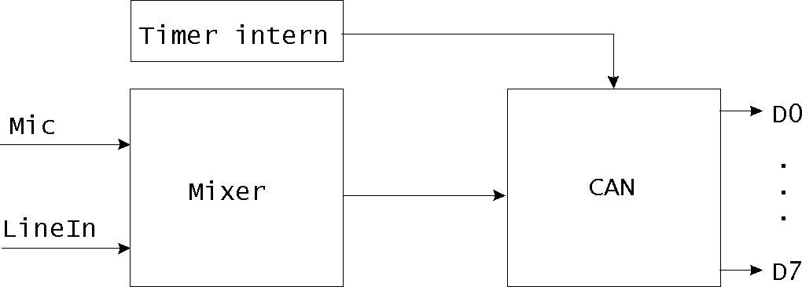
Figura 1:
Porturile plăcii SOUDBLASTER

Tabel 1:

02x00h C/MS 1-6 - Data Port Write SB Only
02x00h FM Music - Left Status Port Read SBPro
02x00h FM Music - Left Register Port Write SBPro
02x01h C/MS 1-6 - Register Port Write SB Only
02x01h FM Music - Left Data Register Write SBPro
02x02h C/MS7-12 - Data Port Write SB Only
02x02h FM Music - Right Status Port Read SBPro
02x02h FM Music - Right Register Port Write SBPro
02x03h C/MS7-12 - Register Port Write SB Only
02x03h FM Music - Right Data Register Write SBPro
02x04h Mixer - Register Port Write SBPro
02x05h Mixer - Data Register Read/Write SBPro
02x06h DSP - Reset Write SB
02x08h FM Music - Compatible Status Port Read SB
02x08h FM Music - Compatible Register Port Write SB
02x09h FM Music - Compatible Data Register Write SB
02x0Ah DSP - Read Data Read SB
02x0Ch DSP - Write Data or Command Write SB
02x0Ch DSP - Write Buffer Status Read SB
02x0Dh DSP - Timer Interrupt Clear Read SB16???
02x0Eh DSP - Data Available Status Read SB
02x0Eh DSP - IRQ Acknowledge, 8-bit Read SB
02x0Fh DSP - IRQ Acknowledge, 16-bit Read SB16
02x10h CD-ROM - Data Register Read SBPro
02x10h CD-ROM - Command Port Write SBPro
02x11h CD-ROM - Status Port Read SBPro
02x12h CD-ROM - Reset Write SBPro
02x13h CD-ROM - Enable Write SBPro
0388h AdLib - Status Port Read SB
0388h AdLib - Register Port Write SB
0389h AdLib - Data Register Write SB
038Ah Advanced AdLib - Status Port Read SB16
038Ah Advanced AdLib - Register Port Write SB16
038Bh Advanced AdLib - Data Register Write SB16
03x00h MPU-401 - Data Port Read/Write SB16???
03x01h MPU-401 - Status Port Read SB16???
03x01h MPU-401 - Command Port Write SB16???
0200h-0207h Joystick Varies SB

Comenzi DSP

Tabel 2:
003h ASP Status SB16ASP
004h DSP Status (Obsolete) SB2.0-Pro2
004h ASP ??? SB16ASP
005h ASP ??? SB16ASP
010h Direct DAC, 8-bit SB
014h DMA DAC, 8-bit SB
016h DMA DAC, 2-bit ADPCM SB
017h DMA DAC, 2-bit ADPCM Reference SB
01Ch Auto-Initialize DMA DAC, 8-bit SB2.0
01Fh Auto-Initialize DMA DAC, 2-bit ADPCM Reference SB2.0
020h Direct ADC, 8-bit SB
024h DMA ADC, 8-bit SB
028h Direct ADC, 8-bit (Burst) SB-Pro2
02Ch Auto-Initialize DMA ADC, 8-bit SB2.0
030h MIDI Read Poll SB
031h MIDI Read Interrupt SB
032h MIDI Read Timestamp Poll SB???
033h MIDI Read Timestamp Interrupt SB???
034h MIDI Read Poll + Write Poll (UART) SB2.0
035h MIDI Read Interrupt + Write Poll (UART) SB2.0???
037h MIDI Read Timestamp Interrupt + Write Poll (UART) SB2.0???
038h MIDI Write Poll SB
040h Set Time Constant SB
041h Set Sample Rate SB16
045h Continue Auto-Initialize DMA, 8-bit SB16
047h Continue Auto-Initialize DMA, 16-bit SB16
048h Set DMA Block Size SB2.0
074h DMA DAC, 4-bit ADPCM SB
075h DMA DAC, 4-bit ADPCM Reference SB
076h DMA DAC, 2.6-bit ADPCM SB
077h DMA DAC, 2.6-bit ADPCM Reference SB
07Dh Auto-Initialize DMA DAC, 4-bit ADPCM Reference SB2.0
07Fh Auto-Initialize DMA DAC, 2.6-bit ADPCM Reference SB2.0
080h Silence DAC SB
090h Auto-Initialize DMA DAC, 8-bit (High Speed) SB2.0-Pro2
098h Auto-Initialize DMA ADC, 8-bit (High Speed) SB2.0-Pro2
0A0h Disable Stereo Input Mode SBPro Only
0A8h Enable Stereo Input Mode SBPro Only
0Bxh/0Cxh Generic DAC/ADC DMA (16-bit, 8-bit) SB16
0D0h Halt DMA Operation, 8-bit SB
0D1h Enable Speaker SB
0D3h Disable Speaker SB
0D4h Continue DMA Operation, 8-bit SB
0D5h Halt DMA Operation, 16-bit SB16
0D6h Continue DMA Operation, 16-bit SB16
0D8h Speaker Status SB
0D9h Exit Auto-Initialize DMA Operation, 16-bit SB16
0DAh Exit Auto-Initialize DMA Operation, 8-bit SB2.0
0E0h DSP Identification SB2.0
0E1h DSP Version SB
0E3h DSP Copyright SBPro2???
0E4h Write Test Register SB2.0
0E8h Read Test Register SB2.0
0F0h Sine Generator SB
0F1h DSP Auxiliary Status (Obsolete) SB-Pro2
0F2h IRQ Request, 8-bit SB
0F3h IRQ Request, 16-bit SB16
0FBh DSP Status SB16
0FCh DSP Auxiliary Status SB16
0FDh DSP Command Status SB16

Programul foloseşte următoarele registre:

02x06h DSP – Reset
02x0Ah DSP - Read Data
02x0Ch DSP - Write Data or Command
02x0Ch DSP - Write Buffer Status
02x0Dh DSP - Timer Interrupt Clear
02x0Eh DSP - Data Available Status

Comenzi DSP:
014h DMA DAC, 8-bit
024h DMA ADC, 8-bit
040h Set Time Constant
0D1h Enable Speaker
0D3h Disable Speaker

02x06h DSP - Reset
Descriere
Resetează DSPul, terminând toate operaţiile anterioare.

Procedura
- Scrie 001h
- Aşteaptă 3.3us minimum
- Scrie 000h
- şteaptă 100us maximum pentru DSP Data Available(02x0Eh)
- Citire 0xAA de la DSP Read Data (02x0Ah)

02x0Ah DSP - Read Data
Descriere
Portul de intrare pentru citirea DSP octet.

Procedura
- Aşteapta până când bitul 7=1 de la DSP Data Abailable Status(02x0Eh read)
- Citire octet de pe DSP Read Data port (02x0Ah read)

02x0Ch DSP - Write Data or Command
Descriere
Portul de iesire pentru comenzi DSP si pentru date.

Procedura
- Aşteaptă până când bitul 7=1 de la DSP Write Buffer Status (02x0Ch read)
- Scriere octet la DSP Write Data or Command port (02x0Ch write)

02x0Ch DSP - Write Buffer Status
Descriere
Indică dacă DSPul poate să primeşte date prin DSP Write Data or Command port (02x0Ch write).

Procedura
- Aşteaptă până când bitul 7=1 de la DSP Write Buffer Status (02x0Ch read)
- Scriere octet la DSP Write Data or Command port (02x0Ch write)

02x0Eh DSP - Data Available Status
Descriere
Indică dacă DSPul are date disponibile pe portul DSP Read Data port (02x0Ah read).

Procedura
- Aşteapta până când bitul 7=1 de la DSP Data Abailable Status(02x0Eh read)
- Citire octet de pe DSP Read Data port (02x0Ah read)

Comenzi DSP

014h DMA DAC, 8-bit

COMMAND->LENGTHLOBYTE->LENGTHHIBYTE

Descriere
Iniţializează transfer DMA pe 8 biţi.

Procedura
- Instalare procedura de întrerupere,actualizare masca pic.
- Setare constanta de timp,sau timpul de eşantionare (Set Time Constant(040h))
- Comanda Enable Speaker (0D1h)
- Setare controlerul DMA (mode = 048h + channel)
- Comanda DMA DAC,8-bit (014h)
- Acknowledge IRQ PIC & SB
- Comanda Disable Speaker (0D3h)

LENGTH = SAMPLES - 1

040h Set Time Constant

COMMAND->TIMEBYTE

Descriere
Seteză rate de eşantionare

Formula
TimeConstant = 256 - (1000000 / (SampleChannels * SampleRate))

0D1h Enable Speaker

COMMAND

Descriere
Activeazâ ieşirea

0D3h Disable Speaker

COMMAND

Descriere
Dezactivează ieşirea

Funcţii legate de placa SOUNDBLASTER se găsesc în fişierul sblaster.c

#ifndef SBH
#include "sblaste.h"
#endif

unsigned char sbdmaon;

void interrupt(*oldintvector)(void);
void interrupt SB_Handler(void);

void interrupt SB_Handler(void){
sbdmaon=0;
inp(DSP_IRQAck8);
outp(INT_Controller,PIC_IRQAck);
}

void DSP_Write(unsigned char a){
while (inp(DSP_WriteBufferStatus) & 0x80); //bit7=0 ->ready;
outp(DSP_WriteDataOrCommand,a);
}

unsigned char DSP_Read(void){
long timeout=10000L;

//bit 7=1->ready
while( (!inp(DSP_DataAvailableStatus)&0x80) && (timeout--) );
return inp(DSP_ReadData);
}

unsigned char DSP_Reset(void){
unsigned char i=100;

outp(DSP_ResetPort,1);
outp(DSP_ResetPort,0);

while((DSP_Read()!=0xAA) && (i--) );
return i;
}

void SB_InstallHandler(void){
disable();

outp(PIC_Maskport, (inp(PIC_Maskport)|IRQ_Stop));
oldintvector = getvect(IRQ_Intvector);
setvect(IRQ_Intvector, SB_Handler);
outp(PIC_Maskport, (inp(PIC_Maskport)&IRQ_Start));
enable();
}

void SB_UninstallHandler(void){
disable();

outp(PIC_Maskport, (inp(PIC_Maskport)|IRQ_Stop));
setvect(IRQ_Intvector, oldintvector);
enable();
}

Controlerul DMA

Controlerul DMA este folosit pentru transfer de date între echipamente de intrare/iesire (porturi I/O) şi memorie, fără intervenţia procesorului. Este folosit în general de catre unităţi de disk, hard diskuri, dar poate fi folosit pentru orice port I/O cât timp nu interferează cu alte unităţi standard.
Setarea controlerului DMA pentru transfer DMA
- Activare masca canal
- Stergere byte pointer
- Configurare modul de transfer
- Scriere adresa de pagina
- Scriere adresa de deplasament (offset)
- Scriere lungime-1
- Deactivare masca canal

Adresa DMA este pe 20 biţi, această adresă este calculată în program.Registrul de adresa de pagina este setat cu o valoare pe 4 biţi care reprezintâ biţii 16-19 din adresa DMA de 20 biţi.Memoria alocata transferului DMA trebuie să încapă pe o pagina de 64Koctet. În program această condiţie este satisfăcut alocând de două ori mai multă memorie(în total max 64Koctet ), pentru transferul DMA, iar dacă aceasta zomă de memorie nu încapă pe o pagină de 64Kocteţi.Adresa de început este mărit pînă la începutul paginii 2. Astfel zona de memorie sigur, încapă pe pagina aceasta.

Despre controlerul DMA

The original PC supports four 8-bit DMA channels, across a 20-bit address
space, using an Intel 8237A DMA controller chip. The AT supports seven
DMA channels by cascading a second 8237A DMA controller. The differences
between PC and AT DMA are covered at the end of this section.

Channel Usage in PC and XT
_______ ____________________________________
0 memory refresh (highest priority)
1 not used
2 diskette adapter
3 hard disk adapter (lowest priority)

Note: All PC-compatibles use DMA channel 0 for memory refresh. If
memory is not refreshed as set by the BIOS, data in RAM will
degrade within a few hundredths of a second. It is wise to avoid
monkeying with DMA port settings.

Port Description
____ ______________________________________________________________________
000H-007H DMA base address an offset registers
All are 16-bit registers: read/write the low byte, then the high byte
at the same I/O port. Base addresses are offsets from a DMA Page
(see below).

000H Write: DMA channel 0 base address (also sets current address)
Read: DMA channel 0 current address
001H Write: DMA channel 0 base address and word count
Read: DMA channel 0 current word count
002H Write: DMA channel 1 base address
Read: DMA channel 1 current address
003H Write: DMA channel 1 base address and word count
Read: DMA channel 1 current word count
004H Write: DMA channel 2 base address (diskette adapter)
Read: DMA channel 2 current address "
005H Write: DMA channel 2 base address and word count "
Read: DMA channel 2 current word count "
006H Write: DMA channel 3 base address (hard disk adapter)
Read: DMA channel 3 current address "
007H Write: DMA channel 3 base address and word count "
Read: DMA channel 3 current word count "
---- -----------------------------------------------------------------------
008H-00fH DMA control/status registers
008H Write: DMA command register
+7-6-5-4-3-2-1-0+
¦ ¦ ¦ ¦ ¦ ¦ ¦ ¦ ¦
+---------------+ bit
¦ ¦ ¦ ¦ ¦ ¦ ¦ +- 0: 1=enable memory-to-memory DMA (ch0-ch1)
¦ ¦ ¦ ¦ ¦ ¦ +--- 1: 1=enable Ch0 address hold
¦ ¦ ¦ ¦ ¦ +----- 2: 1=disable controller
¦ ¦ ¦ ¦ +------- 3: 1=select compressed timing mode
¦ ¦ ¦ +--------- 4: 1=enable rotating priority
¦ ¦ +----------- 5: 1=select extended write mode; 0=late write
¦ +------------- 6: 1=select DRQ sensing as active high; 0=low
+--------------- 7: 1=select DACK sensing as active high; 0=low
Read: DMA status register
+7-6-5-4-3-2-1-0+
¦ ¦ ¦ ¦ ¦ ¦ ¦ ¦ ¦
+---------------+ bit
+-----+ +------- 0-3: channel 0-3 has reached terminal count
+------------ 4-7: channel 0-3 has a request pending

009H Write: request register
+7-6-5-4-3-2-1-0+
¦ unused ¦ ¦ ¦
+---------------+ bit
¦ +--- 0-1: select channel (00=0; 01=1; 10=2; 11=3)
+----- 2: 1=set request bit for channel; 0=reset request

00aH Write: single mask bit register
+7-6-5-4-3-2-1-0+
¦ unused ¦ ¦ ¦
+---------------+ bit
¦ +--- 0-1: select channel (00=0; 01=1; 10=2; 11=3)
+----- 2: 1=set mask for channel; 0=clear mask (enable)

00bH Write: mode register
+7-6-5-4-3-2-1-0+
¦ ¦ ¦ ¦ ¦ ¦ ¦ ¦ ¦
+---------------+ bit
+-+ ¦ ¦ +-+ +--- 0-1: select channel (00=0; 01=1; 10=2; 11=3)
¦ ¦ ¦ +------ 2-3: xfer type: 00=verify (nop); 01=write; 10=read
¦ ¦ +--------- 4: 1=enable auto-initialization
¦ +----------- 5: 1=select addr increment; 0=address decrement
+-------------- 6-7: 00=demand mode; 01=single
10=block; 11=cascade

00cH Write: clear byte pointer flip-flop. Any write clears the flip-flop
so that the next write to any of the 16-bit registers is
decoded as the low byte. The next is the high byte, then next
is low, etc.

00dH Write: master clear. Any OUT clears the ctrlr (must be re-init'd)
Read: temporary reg. Last byte in memory-to-memory xfer (not used)

00eH Write: Clear mask registers. Any OUT enables all 4 channels.

00fH Write: master clear. Clear or mask any or all of the channels.
+7-6-5-4-3-2-1-0+
¦ ¦ ¦ ¦ ¦ ¦
+---------------+ bit
¦ ¦ ¦ +- 0: 1=mask channel 0; 0=enable
¦ ¦ +--- 1: 1=mask channel 1;
¦ +----- 2: 1=mask channel 2;
+------- 3: 1=mask channel 3;
Read: temporary reg. Last byte in memory-to-memory xfer (not used)

081H-08fH DMA page registers.
To select a starting address for a DMA operation, do an OUT to the
page register (ports 81H-83H) for the selected channel then set the
base address (ports 00H-07H) for the channel. A page register is set
with a 4-bit value that represents bits 16-19 of the 20-bit DMA
address. Since the current address is a 16-bit value, it is not
possible to cross a 64K boundary (e.g., address 1000:0, 2000:0, etc.)
with a DMA operation.

081H Channel 2 page register (diskette DMA)

082H Channel 3 page register (hard disk DMA)

083H Channel 1 page register

____________________________________________________________________________
_¦AT DMA__
The DMA system on the AT is basically upwardly-compatible with PC and XT
DMA. In addition to the four 8-bit channels of the PC, the AT adds a
second 8237A-5 DMA controller which supports channels 4-7.

Channel Usage in AT
_______ ________________________________________________________________
0 spare -+
1 SDLC (Synchronous Data Link Control) ¦- 8-bit DMA channels
2 diskette adapter ¦
3 hard disk adapter -+
4 (controller 2) cascade for controller 1 -+
5 spare ¦- 16-bit DMA channels
6 spare ¦
7 spare -+

---- -----------------------------------------------------------------------
081H-08fH DMA page registers. On the AT, all 8 bits of the Page registers
are used. They become the high 8-bits of a 24-bit address space
(with the low 16-bits being set in a channel's base/current address
register). The page size is 128K (64K words) so DMA transfers must not
cross a 128K boundary (e.g., address 2000:0, 4000:0, 6000:0, etc.)

081H Channel 2 page register (diskette DMA) (address bits 16-23)
082H Channel 3 page register (hard disk DMA) (address bits 16-23)
083H Channel 1 page register (address bits 16-23)
087H Channel 0 page register (address bits 16-23)
089H Channel 6 page register (address bits 17-23)
08bH Channel 5 page register (address bits 17-23)
08aH Channel 7 page register (address bits 17-23)
08fH refresh
---- -----------------------------------------------------------------------
0c0H-0dfH AT DMA controller registers for 16-bit DMA I/O. Channels 0-3 work
with 8-bit I/O as in the PC. Additional channels 4-7 support 16-bit
device-to-memory and memory-to-device transfers. Transfers for these
channels always start on a word boundary and all addresses and counts
are for 16-bit words (e.g., a base address of 123H actually refers to
offset 246H from the page for that channel).

0c0H Channel 4 base and current address (bits 1-16; bit 0 assumed 0)
0c2H Channel 4 current word count
0c4H Channel 5 base and current address (bits 1-16)
0c6H Channel 5 current word count
0c8H Channel 6 base and current address (bits 1-16)
0caH Channel 6 current word count
0ccH Channel 7 base and current address (bits 1-16)
0ceH Channel 7 current word count
---- -----------------------------------------------------------------------
0d0H-0dfH AT DMA control/status registers
0d0H Write: command register
Read: status register
0d2H Write request register
0d4H Write single mask register bit
0d6H Write Mode register
0d8H Clear byte pointer flip-flop
0daH Write: master clear
Read: temporary register
0dcH Clear mask register
0deH Write all mask register bits
---- -----------------------------------------------------------------------

Funcţii legate de controlerul DMA se găsesc în fişierul dma_mem.c.

//all functions for 8 bit dma

#define getlinearaddr(p) ((unsigned long)FP_SEG(p)*16 + (unsigned long)FP_OFF(p))

int DMA_AllocMem(unsigned long size){
unsigned long ap;
dmabuffer=farmalloc(2*size);
if(dmabuffer==NULL)return 0;

dmaptr = (unsigned char far *)dmabuffer;

if( (( getlinearaddr(dmaptr) % 65536L) + size )> 65536L)
{
//dma 64k block override
// dmaptr +=size;

buf_addr=getlinearaddr(dmaptr);
buf_addr+=0x0FFFFL;
buf_addr&=0xF0000L;
ap=(buf_addr>>16)&15;
dmaptr=MK_FP(((unsigned short)ap<<12)&0xF000,0);

printf("->Second DMA buf choosed<-");
}
else printf("->FIRST DMA buf choosed<-");
dmaptr1=dmaptr;

buf_addr = getlinearaddr(dmaptr);
buf_page = (unsigned char)((buf_addr >> 16)&0x000F);
buf_ofs = (unsigned int)((buf_addr) % 65536L);

printf("\nDMA buf size: %8.0f",(float)size);
printf("\nbuf_adr %8.0f",(float)buf_addr);
printf("\nbuf_page %8.0f",(float)buf_page);
printf("\nbuf_ofs %8.0f",(float)buf_ofs);

return 1;
}

void DMA_DAC8Start(void){
sbdmaon=1;
/* Program DMA controller */
outp(DMA_MaskPort, SB_DMA+4); //sn dma 0..3
outp(DMA_ClearFlipFlop, 0x00); // -lo -hi
outp(DMA_ModePort, DMA_WantedMode);
outp(DMA_BaseAddrPort, LO(buf_ofs));
outp(DMA_BaseAddrPort, HI(buf_ofs));

outp(DMA_CountPort, LO(DMA_Length-1));
outp(DMA_CountPort, HI(DMA_Length-1));
outp(DMA_PagePort, buf_page);

outp(DMA_MaskPort, SB_DMA);
//Program the SB
//set time constant
DSP_Write(DSPcm_SetTimeConstant);
DSP_Write(245);//165 //245 //210
//use 8 bit mono no aoutoinit
DSP_Write(DSPcm_DMADAC8);
DSP_Write(LO(DMA_Length-1));
DSP_Write(HI(DMA_Length-1));

//!! TRANSFER STARTS NOW !! --------------------------
}

void DMA_ADC8Start ( unsigned short len )
// len = number of bytes to record to unsigned char *aligned (<=65000)
{
len--;
sbdmaon=1;
// tc = time constant = 256L - (1000000UL/samples per second)

// inp(0x022E);
// DSP_Write(0x40);
// DSP_Write(245);

DSP_Write(DSPcm_SetTimeConstant);
DSP_Write(245);//165 //245 //210

outp(DMA_MaskPort, 5); //sn dma 0..3
outp(DMA_ClearFlipFlop, 0x00); // -lo -hi
outp(DMA_ModePort, 0x45);
outp(DMA_BaseAddrPort, LO(buf_ofs));

outp(DMA_BaseAddrPort, HI(buf_ofs));

outp(DMA_CountPort, LO(len));
outp(DMA_CountPort, HI(len));
outp(DMA_PagePort, buf_page);
outp(DMA_MaskPort, 1); //sn dma 0..3

DSP_Write(0x24);
DSP_Write(LO(len));
DSP_Write(HI(len));

}

void DMA_FreeMem(void){
farfree(dmabuffer);
}

Funcţiile de intercorelaţie şi de autocorelaţie

Funcţia de autocorelaţie
(1)

Funcţia de intercorelaţie$ϕ\text{xx}(τ)={\text{lim}}_{T−∞}\frac{1}{T}\int_{o}^{T}{x(t)x(t+τ)\text{dt}}$$ϕ\text{xy}(τ)={\text{lim}}_{T−∞}\frac{1}{T}\int_{o}^{T}{x(t)y(t+τ)\text{dt}}$
$ϕ\text{xx}(n)=\frac{1}{N}\sum_{k=1}^{N}{x(k)x(k+n)}$$ϕ\text{xy}(n)=\frac{1}{N}\sum_{k=1}^{N}{x(k)y(k+n)}$
(3)
În program sunt implementate funcţiile (2) şi (4) pentru n>=0.
(2)
(4)

Funcţiile legate de analiza semnalelor ( funcţia de autocorelaţie şi intercorelaţie ) se află în fişierul analysis.c

void Autocorrelation(unsigned char *adat,
unsigned int nn,
int x,
int y,
char param){
unsigned char b;
unsigned char *ptr,*pxn,*pxn2;
unsigned char xk,xn;
double suma=0;
const per=2;
int maxim=0;
int vx=x,vy=y,vy_o=0;
int k,n;

if(param) {fliprectangle(x-1-1,y-127/per-1,x+nn+1,y+128/per+1);return;}

ptr=adat;
pxn=adat;

for(n=0;n<nn;n++)
{
//suma
pxn++;
pxn2=pxn;
ptr=adat;
vx++;
suma=0;
for(k=1;k<nn;k++){
xk=*ptr;
ptr++;
if(n+k<nn){
xn=*pxn2;
pxn2++;
}
else xn=127;

suma+=(xk-127)*(xn-127);
}//k
suma/=nn;

vy=(int)(suma/5);
if(vy>127/per)vy=127/per;
if(vy<-127/per)vy=-127/per;
if(vy>maxim)maxim=vy;
// putpixel(vx,y+vy,15);
setcolor(15);
line(vx,-vy+y,vx-1,-vy_o+y);
vy_o=vy;

}//n
}

void Intercorrelation(unsigned char *adat,
unsigned int nn,
int x,
int y,
char param){
unsigned char b;
unsigned char *ptr,*pxn,*pxn2;
unsigned char xk,xn;
double suma=0;
const per=2;

int maxim=0;
int vx=x,vy=y,vy_o=0;

int k,n;

double t=0;
double f=200;
double A=80;
double jel;

ptr=adat;
pxn=adat;
if(param) {fliprectangle(x-1-1,y-127/per-1,x+nn+1,y+128/per+1);return;}

for(n=0;n<nn;n++)
{
//suma
ptr=adat;
vx++;
suma=0;
for(k=1;k<nn;k++){
xk=*ptr;
ptr++;
if(n+k<nn){
//sinus 800hz 7ns 0 - nn
// t=((n+1)/nn)*(7/1000);
t=(dcount*((n+k)+0.1))/((nn+0.1)*1000);
jel=(A*sin(2*3.1416*f*t));
xn=(char)(jel)/per;
}
else xn=0;

suma+=(xk-127)*(xn);

}//k
suma/=nn;

vy=(int)(suma/50);

if(vy>127/per)vy=127/per;
if(vy<-127/per)vy=-127/per;
if(vy>maxim)maxim=vy;

setcolor(15);
line(vx,-vy+y,vx-1,-vy_o+y);

vy_o=vy;

}//n
}

Fişierele programului

123.c –program principal
sblaster.h
sblaster.c
mt.c
analysis.c
dma_mem.c
fileio.c

Nu toate fişierele şi funcţiile sunt folosite de programul final din aceste fişiere. Unele funcţii au fost folosite în etapa scrierii, testării programului.

Variabile din program

VGAFLIPPAGE – afişare folosind două pagini VGA (se poate să nu funcţioneze la unele placi VGA)
DRAFTMODE – afişare simplificată pentru imprimantă

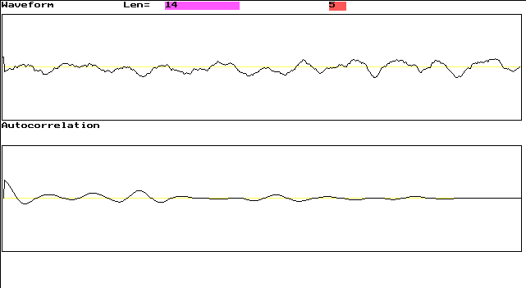
Imagini din program

Len=14 Lungimea semnalului din grafic în milisecunde.În acest caz 14ms.
5 -Cadre afişate pe secundă (fps)
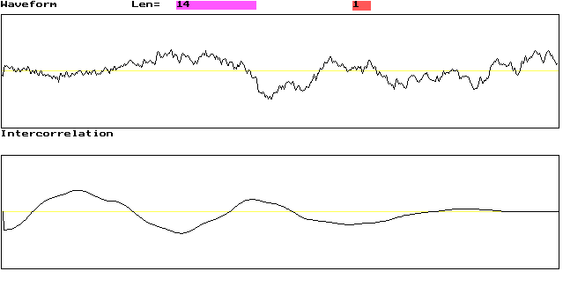
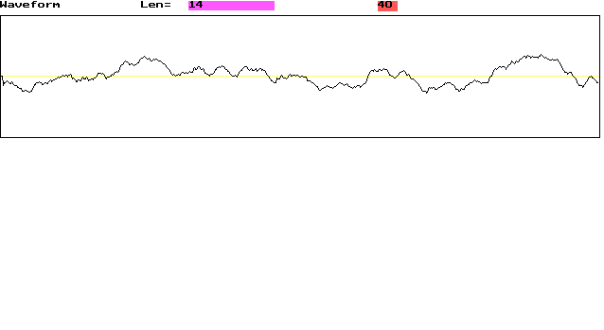
Bibliografie
[1] Cursuri
[2] Internet
[3] TechHelp

