Endangered Species
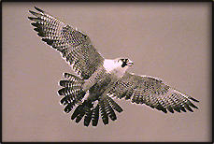

American Peregrine Falcon

In 1988, at a site now inundated by Greers Ferry Lake, peregrine falcons reared their young. Over a century passed before fledgling peregrines returned to Arkansas.
In June 1993, an environmental team flew to Minnesota and picked up five fledgling falcons. These birds were given a new home at the Arkansas Power & Light Company power station on the White River in Independence County. They were acclimated to their new area in a hacking station 300 feet above the ground, then released when ready to fly. Three birds survived and were often seen flying near the White and Black rivers.
In 1994, six more Minnesota peregrines were released from a hacking station atop the TCBY Tower in Little Rock, Arkansas's tallest building. It is hoped the relocated falcons will imprint on their new homeland and return to nest on permanent structures built for their use. Reintroductions like these have worked successfully in many other parts of the U.S., thanks in part to falconers who have raised thousands of peregrines in captivity for eventual release.
Although peregrines live on every continent except Antarctica, they are always rare. In Arkansas, they're most likely to be seen from mid-September through mid-May in southern lowlands.
The peregrine's recent history holds a cautionary tale. In the 1950s and '60s, these magnificent birds were nearly wiped out when their food chain was contaminated with pesticides, primarily DDT. All 275 known nesting sites in the eastern U. S. were deserted by 1964. To our good fortune, however, they were saved from extinction. There are now more than 1,200 pairs in North America, a four-fold increase in the last 20 years.
Unfortunately, we still have not roused ourselves to face the real enemy. DDT and other persistent pesticides continue to be manufactured and exported to the Third World, and the chemicals currently used in Western countries may be almost as deadly. Many contend we must change agricultural practices on a global scale; only then will we be heeding the message of hope the falcon brings.

Bald Eagle
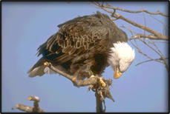
In 1994, America's efforts to save endangered species reached a milestone with the announcement by the U. S. Fish and Wildlife Service that the bald eagle had recovered sufficiently to change its status from endangered to threatened in most of the nation. Bald eagle numbers in the lower 48 states climbed from 417 nesting pairs in 1963 to more than 4,400 pairs in 1994. In addition, 5,000 to 6,000 juvenile bald eagles live in the lower 48. Federal protection and tremendous public support led to this recovery -- through stricter law enforcement, protection of important habitat, reintroduction, a strong public education program and banning of DDT, a pesticide that interfered with normal eggshell production.
The first successful bald eagle nesting since 1930 was reported in Arkansas in 1982. In 1995, 18 pairs of Arkansas eagles successfully fledged young from the nest. An eagle hacking program started by the Game and Fish Commission in 1982 contributed to this resurgence. Young eagles from Minnesota and Wisconsin are brought to the state, raised in "hacking" facilities and released in hopes they will return to raise their young in Arkansas.
Arkansas ranks in the top 10 states in the number of winter bald eagle sightings. Over 1,000 bald eagles are counted each winter, nearly triple the 368 recorded in 1979.

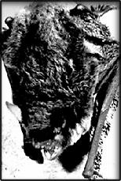
Gray Bat

The gray bat's range is concentrated in the cave regions of Arkansas, Missouri, Kentucky, Tennessee and Alabama, with occasional colonies and individuals in adjacent states. The population is estimated at more than 1.5 million; however, about 95 percent hibernate in only eight caves -- two in Tennessee, three in Missouri, and one each in Kentucky, Alabama and Arkansas. This makes the population extremely vulnerable.
Gray bat numbers decreased significantly during recent decades -- 61 percent in Arkansas, 89 percent in Kentucky, 81 percent in Missouri and 76 percent in Tennessee and Alabama. The population is now on the upswing, though, as a result of improved breeding success due to better protection measures such as cave gates, fences and informational signs near caves.
One Arkansas hibernation cave houses about 250,000 gray bats, over 15 percent of the total population. About 150,000 gray bats occupy Arkansas caves in summer.
People who disturb hibernation and maternity colonies present one of the greatest threats. Maternity colonies won't tolerate any disturbance, especially when flightless newborn young are present. Thousands of baby bats may be dropped to their deaths or abandoned by panicked parents. If aroused during hibernation, bats increase use of stored fat reserves, and if the disturbance is intense or frequent enough, starvation may result before insects are available in spring.
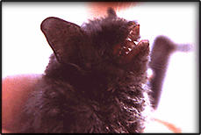
Other factors in the species' decline include vandalism, cave commercialization, pesticide poisoning, natural calamities such as flooding and cave-ins, loss of caves due to inundation by man-made impoundments and possibly a reduction of insect prey over streams that have been degraded by excessive pollution and siltation

Indiana Bat

These small brown bats are known for their remarkable hibernation clusters. Each bat hangs by its feet from the cave ceiling, and as many as 480 have been counted in a single square foot.
Indiana bats range throughout much of the eastern U. S. They number less than 400,000. More than 85 percent hibernate at only seven locations --tow caves and a mine in Missouri, two caves in Indiana and two caves in Kentucky.
A marked decline has been reported in Arkansas populations. Indianas no longer visit 10 caves where they previously hibernated. A Newton County cave that once contained 7,000 hibernating Indiana bats now shelters less than 200.
Currently, only eight Arkansas caves house more than 30 Indianas during their winter hibernation period (October to April). The present Arkansas population (less than 3,000) is half the 1981 size.
The total U. S. population dropped more than 34 percent since 1983. The decline is attributed to commercialization of roosting caves, killing by vandals, disturbances caused by increased numbers of spelunkers and bat banding programs, use of bats as laboratory experimental animals and possible insecticide poisoning. Some winter hibernacula are unstable as a result of blocking or impeding airflow into the caves and thereby changing the cave's climate.
One Arkansas hibernation cave was fenced by the National Park Service to protect Indiana and gray bats. Four additional hibernation caves in the Ozark National Forest and one on Buffalo National River lands are closed to the public and posted with signs to protect bat colonies. Protecting these caves may result in an increase in bat populations at these caves, but experts say it's unlikely Indiana bats will recolonize abandoned caves.
Only male Indiana bats have been found in Arkansas during summer. Females migrate northward to maternity roosts north of the Ozarks.

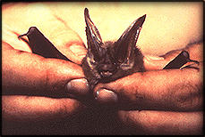
Ozark Big-Eared Bat

This bat is aptly named, for its ears are of comic-book proportions. They're usually curled when the animal rests, like miniature ram's horns. Lump-nosed bat is another common name, a reference to a conspicuous protuberance between the nostril and eye.
About 1,700 Ozark big-eareds remain. Approximately 1,400 inhabit a few caves in eastern Oklahoma. The rest live in two Arkansas caves -- a hibernation cave and a nearby maternity cave in the Ozarks. A Missouri population is now considered extinct.
Human disturbance and wanton killing at caves are the primary reasons for their endangered status. Predation at cave entrances by feral house cats, raccoons, screech owls, bobcats and snakes may also be a factor in their decline.
Intensive efforts to protect Ozark big-eared bats in Oklahoma led the Fish and Wildlife Service to establish the Oklahoma Bat Cave National Wildlife Refuge. The Arkansas hibernation cave is owned and protected by the Natural Heritage Commission, and the owner of the maternity cave has entered into an agreement to protect that site.

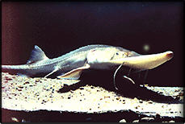
Pallid Sturgeon

Little is known about the pallid sturgeon. This bottom-feeding fish reaches 68 pounds but is rarely observed and infrequently taken on hook-and-line. Even historical records are sketchy, for the species was not formally distinguished from the more-common shovelnose sturgeon until 1905.
Pallid sturgeons are rare throughout their range, which includes the Missouri River and the Mississippi River below St. Louis. Only two records are known for Arkansas, one each from the Mississippi and St. Francis rivers.
The sturgeon's decline should concern all Arkansans, because it is one indication that big river systems like the Mississippi are sick. Creation and maintenance of the Mississippi River as a navigation system has altered the waterway and continues to threaten its viability as an ecosystem. Municipal wastewater discharges, industrial pollution, agricultural runoff and sedimentation due to erosion contaminate the river and pose a major threat tot river species. These problems threaten pallid sturgeons and humans alike.

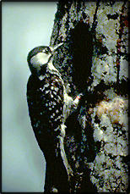
Red-Cockaded Woodpecker

In the mid-1800s, John J. AUDUBON described the red-cockaded woodpecker as abundant in Southern pine forests. Today, 10,000 to 14,000 remain, living in a fragmented range in the southeastern U. S.
Unlike other woodpeckers, the red-cockaded roosts in cavities in live pines. It needs 80 to 120-year-old pines for its cavities, and extensive pine and pine-hardwood forests to meet its foraging requirements. Much of the Southeast has been cleared for agriculture. Many remaining pine forests are unsuitable for the red-cockaded woodpecker. Each year, more areas become unsuitable. Because of the drastic loss and continued decline of habitat, the bird is endangered.
In 1994, 157 active clusters (groups of cavity trees) were found in Arkansas --- 121 on private lands, 35 on federal land (Primarily Felsenthal NWR) and one on state property. Most are in southern counties.
For the species to survive here, private landowners must take positive steps to aid its recovery. Fortunately, that's beginning to happen. In 1993, the Georgia-Pacific Company established a landmark conservation agreement with the Fish and Wildlife Service to hall protect the woodpecker on thousands of acres of company land. Other companies have established similar agreements. The species has also responded favorable to artificial cavity and translocation programs.

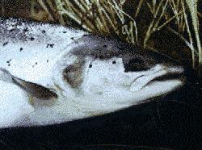
Atlantic Salmon

The Atlantic Salmon (Salmo salar) is often called "The king of the river" (which belongs to the genus Oncorhynchus)
Salmon are fish that can be two metres long and more than forty kilograms in weight.
Their muzzle is long, and they have a lot of teeth in their mouth. Their skin colour changes with the age and sex; when they are at rest the colour on the back is iron-blue and the belly is white, but when they go up the rivers, their back becomes dark.
They have a voracious appetite and can swim very fast when they live in the sea, but when they go up the river, they do not eat until after they spawn, that is why they become weak.
At the moment of their reproduction the salmon comes back to the river, where it was born, to the highest course, and there the females lay the eggs from November till December;.
They make a pit in the stream gravel into which they lay thousands of eggs, and after that they cover them with sand from the bottom. Later, the males cover the eggs with seminal liquid during a week.
After three months birth takes place, and after some states (fry, parr...) they become adults.
In Spain there are salmon in the northern rivers but it has been checked that the number of salmon that go up the rivers is decreasing in an alarming way.
The salmon lives in the seas of the northen hemisphere, and it gets into the European and North American rivers at regular times and it is a relative of the Pacific salmon.
At the beginning of this century there were in the Narcea River (the most important river in Spain as far as salmon are concerned) about five thousand salmon going up the river in a year, nowadays there are hardly one thousand.
There are many causes of depopulation of the Spanish rivers: natural and artificial obstacles, water pollution,overfishing..
We must use different approaches to solve these problems. We could build fish ladders to allow salmon to go upstream, try to purify the current state of the water, regulate and forbide the use of nets and apply sanctions against the dumping of toxic products.
Another method would be through natural and artificial restocking.
The solution is in our hands; what today is easy, tomorrow would be a waste of time.!
Perhaps there does not exist an animal so pursued as the salmon. After a long time in the ocean, where it has suffered considerably because of the voracity of its enemies, and it gets closer to the coast looking for its river to reproduce.
This is when really the salmpn's struggle for life begins because it has to face up to the worst and the most terrible enemy - Man.
Today we are in time, tomorrow it may be too late!!!

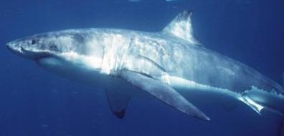
Great White Shark

The Great White is a fish. It has a fin on the top of the body called a dorsil fin.
The Great White can grow from six to twelve metres long. It is a grey blue colour on top of it's body and white on the bottom. The great white shark eats seals, fish, other sharks, carrien of dead whales, octopus and rubbish.
When they have babies, the babies go away or risk getting eaten by the mother.
The great white shark is found in cold waters and warm waters.
Sometimes great white sharks are found in lakes of Australia and New Zealand.
The great white shark is endangered because people are killing them for food and sport.
People are scared of them.
They also are endangered because people are polluting the water.
People should not pollute the ocean. They should not kill great whites for food or sport.
Great white sharks are not man eaters. Leave sharks alone to swim in peace.
We have loved the sea for a long time and we have always wanted to do a project on The great white shark

