The Ideal Gas Equation
The three historically important gas laws derived relationships between two physical properties of a gas, while keeping other properties constant:
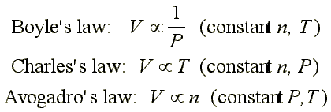
These different relationships can be combined into a single relationship to make a more general gas law:
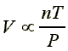
If the proportionality constant is called "R", then we have:
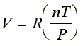
Rearranging to a more familiar form:
This equation is known as the ideal-gas equation
- An "ideal gas" is one whose physical behavior is accurately described by the ideal-gas equation
- The constant R is called the gas constant
  - The value and units of R depend on the units used in determining P, V, n and T
  - Temperature, T, must always be expressed on an absolute-temperature scale (K)
  - The quantity of gas, n, is normally expressed in moles
  - The units chosen for pressure and volume are typically atmospheres (atm) and liters (l), however, other units may be chosen
  - PV can have the units of energy:
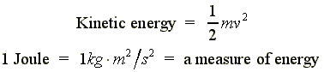
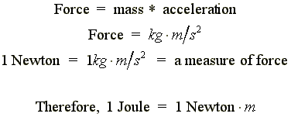
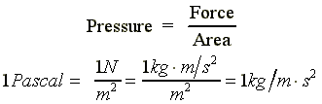
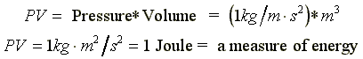
- Therefore, R can include energy units such as Joules or calories
Values for the gas constant R
Units | Value
L atm/mol K | 0.08206
cal/mol K | 1.987
J/mol K | 8.314
m³ Pa/mol K | 8.314
L torr/mol K | 62.36
Example:
If we had 1.0 mol of gas at 1.0 atm of pressure at 0°C (273.15 K), what would be the volume?
PV = nRT
V = nRT/P
V = (1.0 mol)(0.0821 L atm/mol K)(273 K)/(1.0 atm)
V = 22.41 L
- 0 °C and 1 atm pressure are referred to as the standard temperature and pressure (STP)
The molar volume of an ideal gas (any ideal gas) is 22.4 liters at STP
Example: Nitrate salts (NO₃⁻) when heated can produce nitrites (NO₂⁻) plus oxygen (O₂). A sample of potassium nitrate is heated and the O₂ gas produced is collected in a 750 ml flask. The pressure of the gas in the flask is 2.8 atmospheres and the temperature is recorded to be 53.6 °C.
How many moles of O₂ gas were produced?
PV = nRT
n = PV/RT
n = (2.8 atm * 0.75 L) / (0.0821 L atm/mol K * (53.6 + 273)K
n = (2.1 atm L) / (26.81 L atm/mol)
n = 0.078 mol O₂ were produced
Relationship Between the Ideal-Gas Equation and the Gas Laws
Boyle's law, Charles's law and Avogadro's law represent special cases of the ideal gas law
- If the quantity of gas and the temperature are held constant then:
PV = nRT
PV = constant
P = constant * (1/V)
P 1/V (Boyle's law)
- If the quantity of gas and the pressure are held constant then:
PV = nRT
V = (nR/P) * T
V = constant * T
V T (Charles's law)
- If the temperature and pressure are held constant then:
PV = nRT
V = n * (RT/P)
V = constant * n
V n (Avogadro's law)
- A very common situation is that P, V and T are changing for a fixed quantity of gas
PV = nRT
(PV)/T = nR = constant
- Under this situation, (PV/T) is a constant, thus we can compare the system before and after the changes in P, V and/or T:
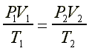
Example:
A 1 liter sample of air at room temperature (25 °C) and pressure (1 atm) is compressed to a volume of 3.3 mls at a pressure of 1000 atm. What is the temperature of the air sample?
